**HISTOGRAMS**

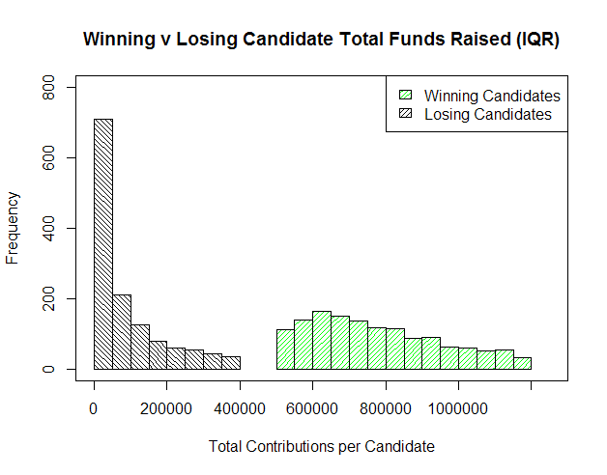

The above histogram provides the total amount of funds raised by each candidate for each Congressional race. Each race is distinguished by year, state, and district. There is a clear dichotomy of funds raised by winning and losing candidates. Not only does this show that the winning candidate always raises more funds than the losing candidate of a particular congressional race, but from the data used, every single winning candidate raised more funds than every single losing candidate of every single race. The data used was the interquartile range of total contributions, which provides a better visual representation without losing the utility of the histogram.

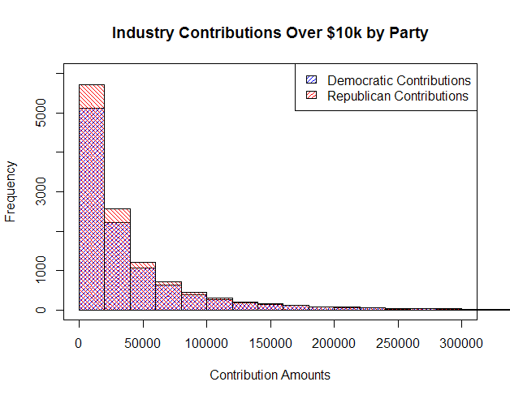

In an effort to show the difference in moneys contributed to the Democratic and Republican parties, the histogram provides visual evidence that Republicans have received the majority of all contributions. The individual contribution amounts are the collective sums of all funds raised from a particular industry to a specific candidate. At nearly every visible level, Republicans received more funds than their Democratic counterparts. Amounts below $10,000 and above $300,000 are considered outliers for the purposes of this histogram and are not represented to provide a better visual representation while maintaining the integrity of the analysis.

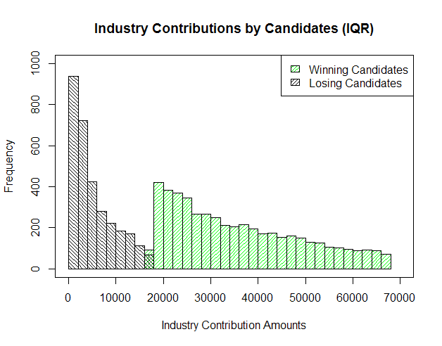

When breaking down each candidate’s total funds raised by industry, the visual evidence appears to show either one of two things, or possibly both: candidates who eventually win their congressional race are better fund raisers, in general, or the more funds an industry contributes to a particular candidate, the higher the likelihood that their chosen candidate will win. In the latter case, this would lead us to believe that there is an underlying purpose of supporting one candidate over another which would be of some benefit to the particular industry itself. The data used was the interquartile range of total contributions, which provides a better visual representation without losing the utility of the histogram.

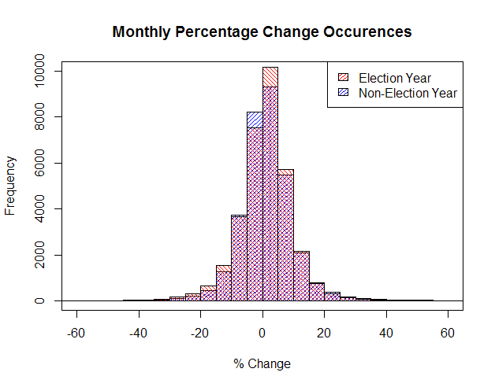

For each month from the beginning of 2004 to September 2015, the percentage change of all adjusted closing prices for stocks listed on the S&P 500 index were calculated and recorded. All percentages occurring in odd-numbered years were classified as “non-election years” while even-numbered years were classified as “election years.” The histogram shows a relatively normal distribution with the balance slightly in favor of positive values, and slightly better performance in election years compared to non-election years.

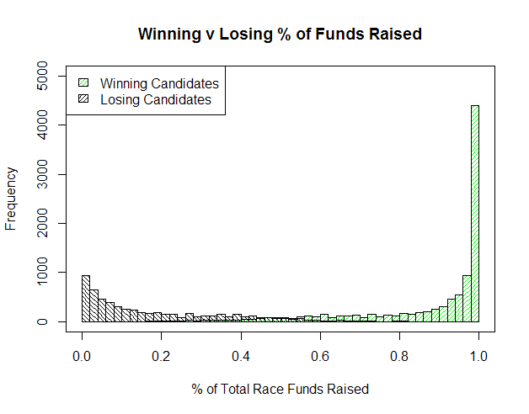

This histogram illustrates the widely-accepted belief that money wins elections. For each election race (distinguished by year, state, and district), each candidate was assigned a percentage of the funds they raised relative to the entire amount of contributions to all candidates involved in the race. It is evident that the higher percentage of funds a candidate raises compared to their competition, the more likely a victory will result. Interestingly, there are some candidates who were able to win their election with less than 20% of total funds raised in a race, and conversely, candidates with more than 80% of all funds raised who lost the election.

**CORRELATIONS**

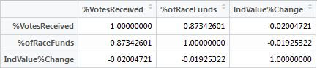

The three variables used to test for correlation were the percentage of votes received by a candidate in an election, the percentage of funds an individual candidate raised from the total amount raised by all candidates, and the percent change of the value of an industry from the beginning of a congressional term to the end of the term. The percentage of votes received by a candidate is the most important factor in determining an election winner. The percentage of funds raised relative to the entire race gives us a measure of support from industries. The industry value percentage change will allow us to observe potential effects the contributions made to candidates may have.

*%VotesReceived / %ofRaceFunds*

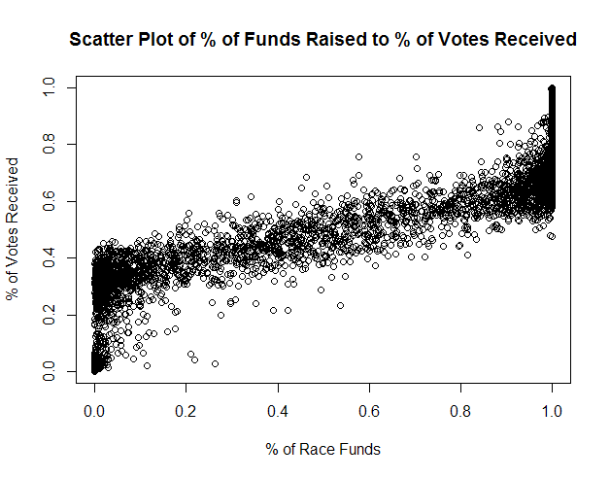

As seen in the histogram “Winning v Losing % of Funds Raised,” there is a very high correlation between the amount of funds raised by a candidate and the amount of votes they receive. A correlation coefficient of over 0.873 indicates a very strong linear relationship between the two variables. In most cases shown in the scatter plot, raising more than 50% of a particular race’s funds resulted in receiving more than 50 % of the total votes.

*%VotesReceived / IndValue%Change*

With a correlation coefficient of -0.020, there is virtually no correlation between the two variables. This result is unremarkable, as there is no intuitive relationship between the percentage of votes a candidate receives relative to the percent change in value of an industry that supports the candidate financially. There may be some type of relationship between the change in value of an industry with the winning or losing candidates that have particular stances on specific issues, but that is beyond the scope of our data.

*%ofRaceFunds / IndValue%Change*

The lowest apparent correlation is between the percentages of funds collected by a candidate and the change in value of an industry between votes. The calculated correlation coefficient is -0.019. Again, there would be no reason to believe that the percentage of funds a candidate collects would have any type of correlation with the change in value of an industry that contributes to the candidate without subsetting the data into more detailed variables.